Pupil premium strategy statement
This statement details our school’s use of pupil premium funding for the academic year 2024/25 to help improve the attainment of our disadvantaged pupils.

It outlines our pupil premium strategy, how we intend to spend the funding in this academic year and the effect that last year’s spending of pupil premium had within our school.

School overview
Detail | Data
School name | Gedney Drove End Primary School
Number of pupils in school | 33
Proportion (%) of pupil premium eligible pupils | 48%
Academic year/years that our current pupil premium strategy plan covers (3 year plans are recommended) | 2025-2028
Date this statement was published | 1st December 2025
Date on which it will be reviewed | 31st July 2026
Statement authorised by | Karyn Herd
Pupil premium lead | Karyn Herd
Governor / Trustee lead | Justine Sands

Funding overview
Detail | Amount
Pupil premium funding allocation this academic year | £22,439
Total budget for this academic year | £22,439

Part A: Pupil premium strategy plan

Statement of intent
When making decisions about the priorities for our pupil premium funding, we carefully consider the individual context of each of our schools. We ensure that our interventions are based on strong research evidence and we utilise the EEF toolkit and associated research to do this. The common barriers that our disadvantaged children face are:
- Lack of parental support
- Early language and communication difficulties
- SEMH issues
- Attendance
We take every child as an individual, and are well aware of their individual needs. We create a bespoke action plan for every child eligible for pupil premium. We are passionate about success for all and strongly belief that a child’s socio-economic background should not be a barrier to future life success. In fact, these children deserve the very best teaching that can be provided so that any gaps on entry are swiftly narrowed.
We strive to ensure the following:
- Quality first teaching for all children is at least good.
- Equity of experience for all children, regardless of disadvantage or SEND
- Curriculum designed around key drivers, created from deficit areas:
Oracy, Cultural Capital, Raising Aspirations and Personal Development
- Provide quality interventions for all children, funded from pupil premium, NTP and catch up monies
- School based Family Support Worker to provide Early Help to families
- Quality SEMH interventions by trained staff
- Attendance for all groups is at least good.
Our aims for our disadvantaged pupils are;
- Narrow the attainment gap between disadvantaged and non-disadvantaged pupils
- For all disadvantaged pupils to make accelerated progress from their starting points
- Support Children’s mental and emotional wellbeing in order for them to have full access to the national curriculum
- That they attend school regularly

Challenges
This details the key challenges to achievement that we have identified among our disadvantaged pupils.
Challenge number | Detail of challenge
1 | Parental engagement in reading and phonics and aspirations for the future
2 | Narrowing the attainment gap across all subjects, in particular children achieving the exceeding standard in writing
3 | Attendance
4 | SEMH difficulties
5 | Language and communication
6 | Lack of experiences outside of school

Intended outcomes
This explains the outcomes we are aiming for by the end of our current strategy plan, and how we will measure whether they have been achieved.

Intended outcome | Success criteria
Rapid acceleration of progress in reading, writing and maths. | Disadvantaged pupils to achieve at least in line with national averages for non-disadvantaged pupils
Improve attainment at greater depth | Disadvantaged pupils to achieve above national averages for greater depth
Improve Attendance of all groups | To ensure that attendance of all groups is above 96%
Improved social and emotional wellbeing of all pupils | Reduction in CPOMS behaviour incidents
Improve early language and oracy skills | Wellcomm assessments shows an improvement in early language acquisitions
Improve children’s access to after school clubs and outside experiences. | For disadvantaged pupils to attend at least one after school club per week or trip per term.

Activity in this academic year
This details how we intend to spend our pupil premium (and recovery premium funding) this academic year to address the challenges listed above.

Teaching
Budgeted cost: £ 4,527
Activity | Evidence that supports this approach | Challenge number(s) addressed
Adaptive teaching training for all teachers, and coaching by SLT.  Coaching by English and Maths lead to improve QFT | Children in all year groups have missed  significant learning due to the pandemic. Weaker teaching requires support SLT release to support CPD to improve QFT. | 2
Phonics lead to be released to work fortnightly with staff | EEF Toolkit Phonic teaching +5  EEF Toolkit Parental engagement +4 | 1

Targeted academic support
Budgeted cost: £15,457
Activity | Evidence that supports this approach | Challenge number(s) addressed
Interventions 1:2:1 and small group language interventions | EEF toolkit language intervention +6 | 1,2 and 5
Interventions 1:2:1 and small group  Fresh start and phonics | EEF toolkit one to one tuition +5  EEF toolkit phonic interventions +5  Fresh start – evidence-based intervention | 1,2 and 5
Interventions 1:2:1 and small group multplication | EEF toolkit one to one tuition +5  EEF toolkit small group tuition +4  Maths counts EEF evidence-based interventions +2 | 1,2 and 5
After school booster provided by teacher | EEF toolkit - After school intervention +3  EEF toolkit one to one tuition +5  EEF toolkit small group tuition +4 | 1,2 and 5

Wider strategies
Budgeted cost: £ 6,854
Activity | Evidence that supports this approach | Challenge number(s) addressed
Family Support Worker post | EEF toolkit behaviour interventions +4  EEF toolkit parental engagement +4  EEF toolkit social and emotional +4  EEF Guidance reports in Social and Emotional learning, behaviour and working with parents.  EEF attendance – developing an effective PP strategy | 1,3 and 4
ELSA | EEF toolkit behaviour interventions +4  EEF toolkit social and emotional +4 | 4
Parental questionnaires for talents for external clubs – signposted and funding made available  PP children directed to attend at least one after school per week. | EEF – extending the school day with enrichment and after school activities. | 6

Total budgeted cost: £26,838

Part B: Review of outcomes in the previous academic year

Pupil premium strategy outcomes
This details the impact that our pupil premium activity had on pupils in the 2024 to 2025 academic year.
As a school we carefully track the attainment and progress of all children, we analyse the progress of children entitled to the pupil premium and governors hold leaders to account for this.
Small cohort sizes make data trends unreliable.
All of our children make good progress from their starting points.

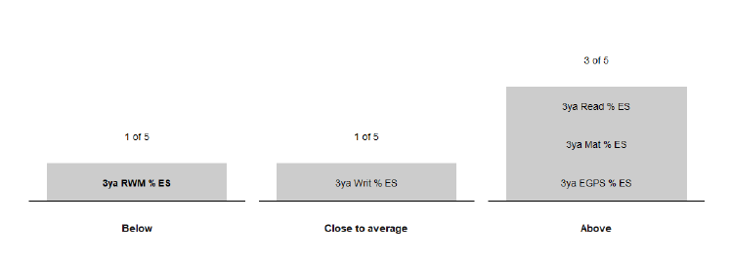
We have utilised additional staffing from across the federation to provide SEMH interventions, this had good impact and reduced the number of serious incidents and ensured that suspensions remain at zero.

The school have had a positive impact on the work it has done to improve attendance, when compared to similar schools the % for disadvantaged pupils attendance is higher.

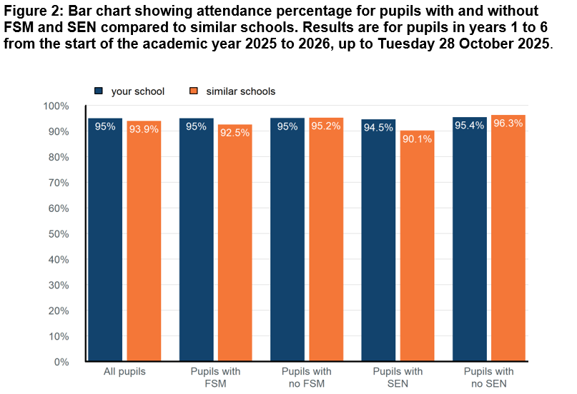

Externally provided programmes
Programme | Provider
Play therapy | Standing Tall Therapies
Art therapy | Jo Willis Art Therapy

Further information
Leadership and Management
Senior leaders have observed out of classroom interventions to ensure that pupils are receiving the same quality of teaching they would expect within whole class sessions.
The biggest impact has been where teacher led interventions have taken place. During monitoring and PPMs, senior leaders have focused on the quality of teaching and learning of all pupils, but have completed work scrutiny specially looking at pupil premium pupils. Senior leaders are monitoring the progress of these pupils using target tracker, challenging targets are used by using FFT 20. Work scrutiny is completed regularly. The pupil premium strategy is created using evidence from the EEF toolkit.
We provide emotional and social support for all of our pupils, but with a particular focus on our pupil premium children.
Quality of teaching and Learning
Our children receive high quality constructive verbal feedback and marking daily, it is our view that children learn best when they have verbal feedback. We encourage our teachers to work with all pupils, but ensure that those requiring support should receive the most amount of time from the teacher to ensure equality of opportunity.
All teachers complete a pupil premium passport with an action plan for their class termly (three times per year) in this they detail who their pupil premium pupils are, what their barriers to learning are and what they will do to support these pupils, either through intervention or targeted QFT.
Our pupil premium strategy is based on evidence from EEF and so our teachers use this to ensure they understand what interventions have the most impact. Our strategies for spending specifically match the barriers for learning for our
disadvantaged pupils. For example, we are aware that our children come into school with poor oracy skills and we often lack parental engagement. We also have a number of our pupils who have suffered emotional trauma and so require emotional interventions along with academic ones.
The targets for pupil premium pupils are aspirational; we use FFT 20 to set challenging and aspirational targets for all pupils including those eligible for the pupil premium funding. The schools provide free breakfast club provision for all pupils.

